**Bank Management System**

Perhaps the simplest software that you can work with is the one that allows you to deal with bank accounts and transactions regarding it. Designing a robust system that allows you to engage in transactions is something that every beginner should get started with. The proposed system is a web-based project that allows you to do everything a bank would allow you to do naturally.



**One should be able to deposit money and withdraw money from a particular account as the user desires.** There should be a validation to allow only a particular amount of cash inflows at any time, as well as to allow withdraws if the balance is sufficient. There should also be the calculation of interest and its addition to the balance every month.



There can be multiple improvements for this project, including adding support for multiple types of accounts. For example, there can be a recurring deposit account that should not allow withdrawals till the maturation date, and the amount is automatically added to the account post the maturation date. We started with this because it is still one of the most popular java projects for beginners.

**FEATURE**

a) Check Balance

b) Deposit Amount

c) Withdraw Amount

d) Previous Transaction

e) Exit



Before using this online banking system, users must complete registration. Users with bank accounts must generate a unique username and secure password to log into the software.  
  
Online Banking Management Software provides the following features to enhance your running banking system, making it easier, more accessible and more effective.

* Bank customers can browse account information such as account ID, account type, account available balance, interest rate, etc. from anywhere through internet services.
* The software will display the cash deposited and the date of deposit.
* Online Bank Management System is designed to provide detailed information about cash withdrawals.You can check the ATM name and location, cash withdrawal time and withdrawal amount.
* online money transfer is he one of the most sought after options by bank customers. Thus, this online software offers detailed online money trading features.
* In addition, this project can display transaction history along with information such as transaction time, amount and type.

Screen :1

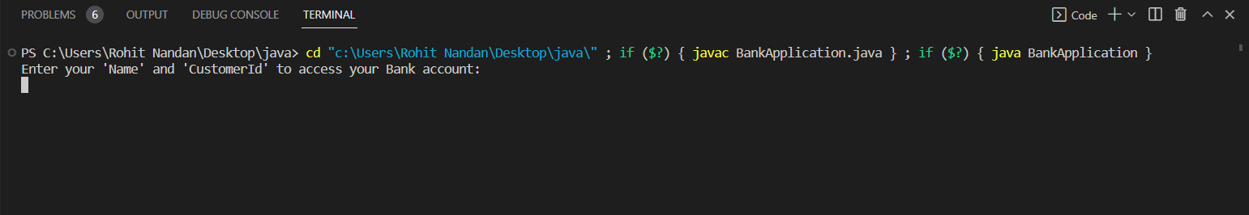

Screen :2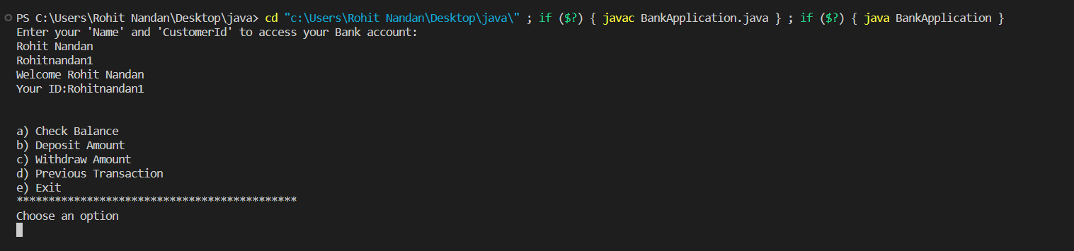

Screen :3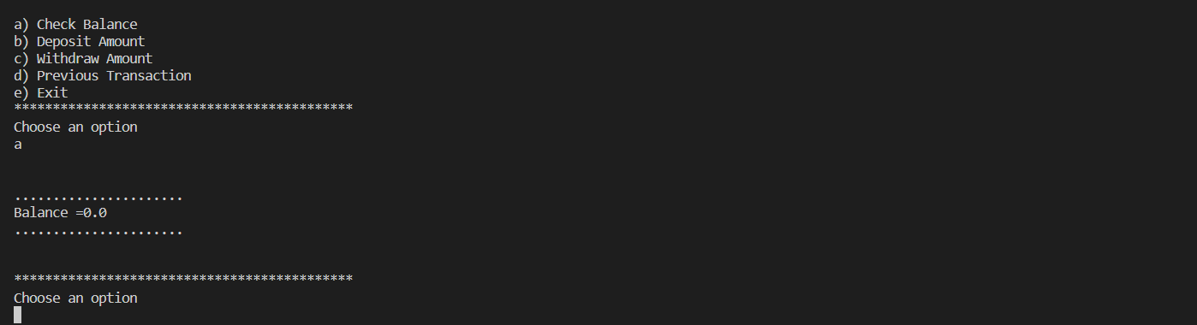

Screen :4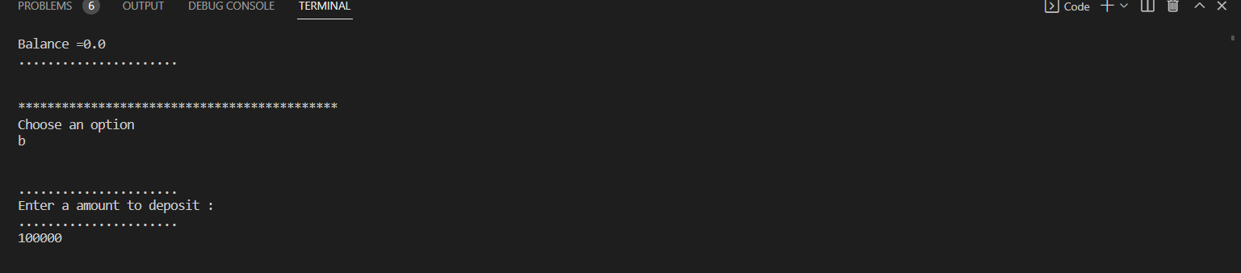

Screen :5